**Sam Lazrak**

**CS 303 Algorithms and Data Structures**

**Homework Assignment 11**

**4/17/18**

1. Work the following Exercises from Chapter 34 of the text:
   1. (3 points) Exercise 34.1-2, page 1060.

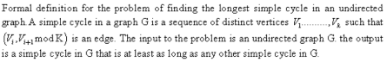

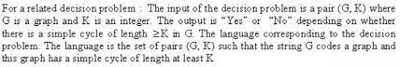

* 1. (6 points) Exercise 34.2-7, page 1066.

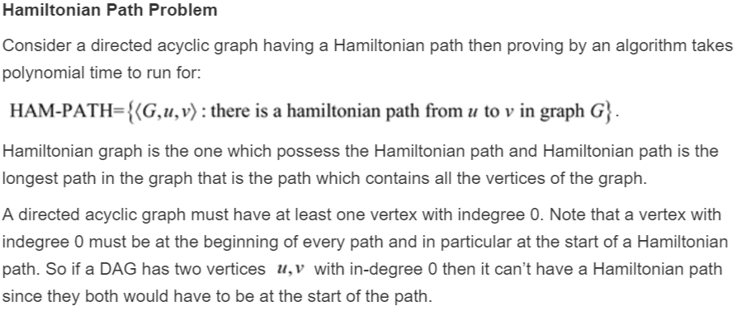Note that the definition of “hamiltonian path” is similar to “hamiltonian cycle” – it visits each vertex in the graph exactly once – but it does not involve a cycle.

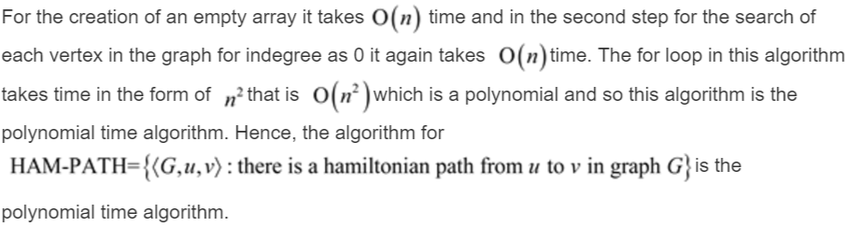

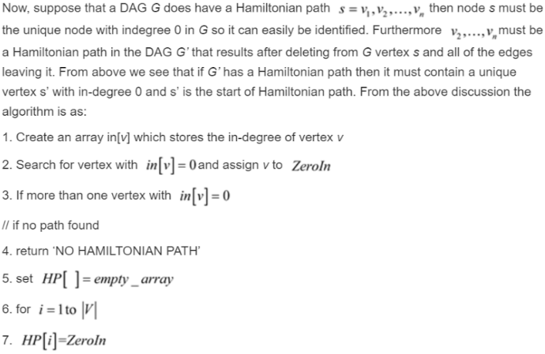

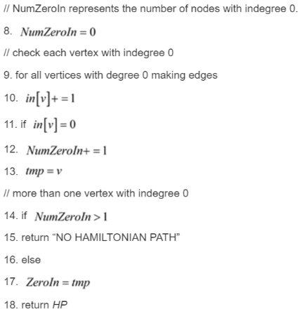

1. Work the following Exercises from Chapter 35 of the text:
   1. 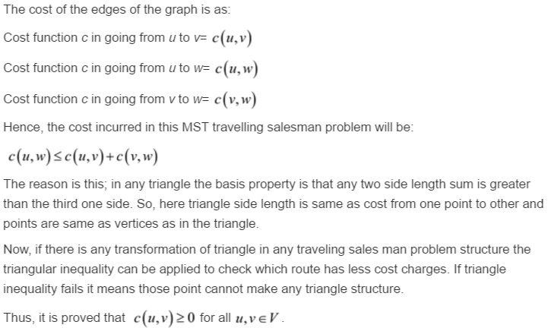(3 points) Exercise 35.2-1, page 1116.

(All answers are obtained from chegg.com)